Receipt Printer / Cash Drawer Troubleshooting

KB0010311

***Receipt Printer / Cash Drawer Troubleshooting***

**Issue:**  
  
If the receipt printer or cash drawer isn't working, here are some common steps to fix the receipt printer in order of easiest fix to hardest fix.

**Resolutions:**

Fix 1:

Power cycle the receipt printer by turning the switch off/on from the front of it.

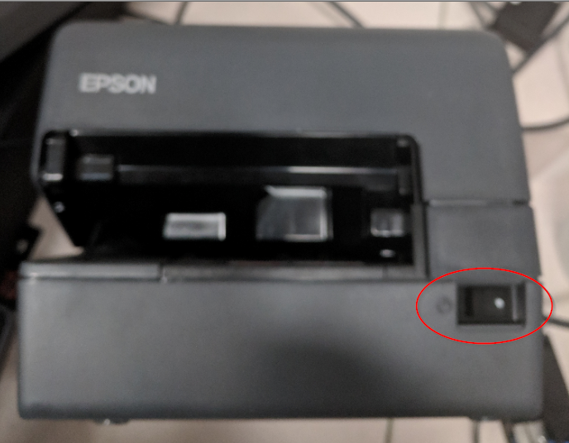

Log into back office and select **Reinitialize Hardware** and hit **Yes** when prompted.

After the hardware is reinitialized you can perform a **No Sale** to test. This is located in **Back Office > Manage Tills > No Sale**.

If No Sale is not available to select, you must reboot the register by doing Ctrl Alt Del and Logout on Register 1 ( and 3 if they have 1) or Signout for the tablet register 2.  (You must click on the word sign out, not on the arrow.)

If this does not work, move on to fix 2.

Fix 2:

Make sure the receipt printer is off first. There will be a set of ports with cables in them on the back of the receipt printer. The cable going into the DK port should be unplugged and plugged back in. It will make a clicking sound. It should look like this:

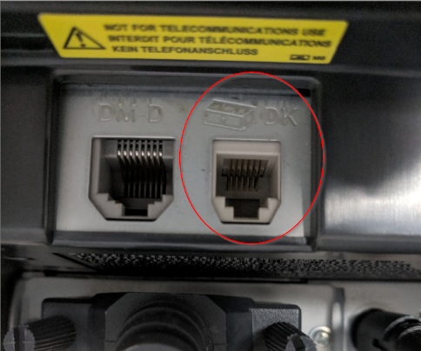

After this is done, Try fix 1 again. Otherwise, you need to check underneath the cash drawer for the same DK port which looks like this:

Unplug that cable and plug it back in. Try Fix 1 again.

Reg 1 or Reg 2 with Desktop: Check to ensure that cables are plugged into the correct ports:

Reg 2 Tablets:

Step 1- Check to ensure that cables are plugged into the correct ports:

Step 2: If “Hardware cannot be detected error” is showing on the reg 2 tablet. Remove panel on right hand side of base, if blue led is not lit, press the red reset button once. If the light does not come on, check the power cable.

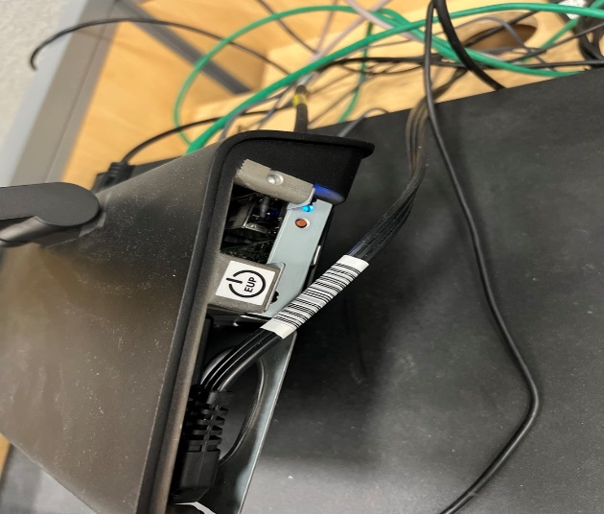

At this point the printer/drawer combo still does not work, it is likely that either the cables going into the DK port are bad, or the Cash Drawer is bad.  You will need to send the store one of these. There is no surefire way to tell which one is broken so use your best judgement in sending new equipment.